**Assignment-14**

**Topics Covered Today**

* Read text file into Pyspark DataFrame
* GroupBy and Aggregate function
* Using Pivot/ UnPivot
* Handling Missing Values Pyspark
* Sorting
* Joins

**Read text file into Pyspark DataFrame**

**Using csv()**

**Using text()**

**Using format()**

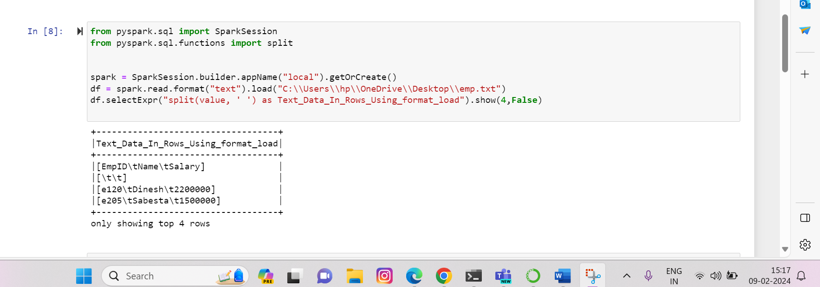

**Adding a new column**

**Using lit()**

**From an existing column**

**Using concat_ws()**

**Using if not in()**

**GroupBy and Aggregate functions**

**With sum()**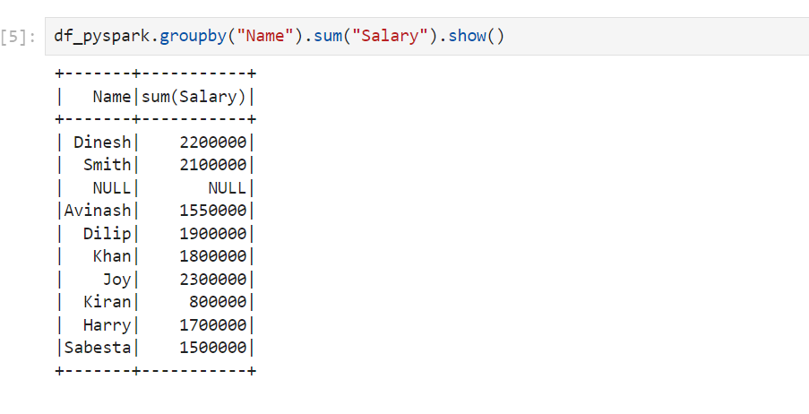

**Using Pivot/ UnPivot**

**Spark SQL provides pivot() function to rotate the data from one column into multiple columns (transpose row to column).**

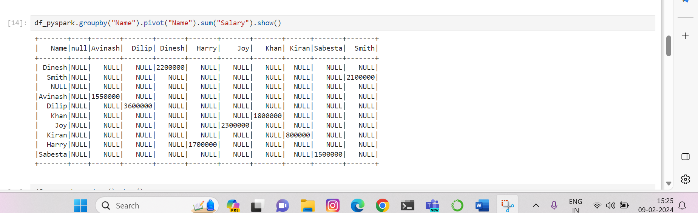

**Handling Missing Values Pyspark**

**Dropping rows based on null values:**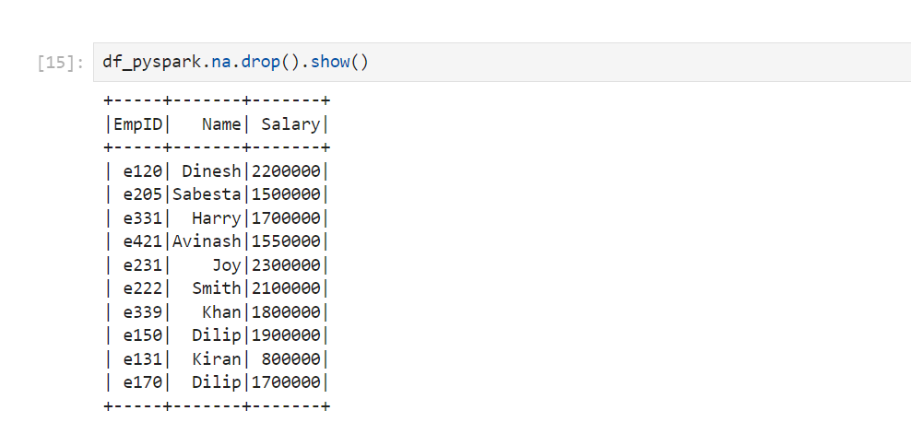

**Using how=”any”:**

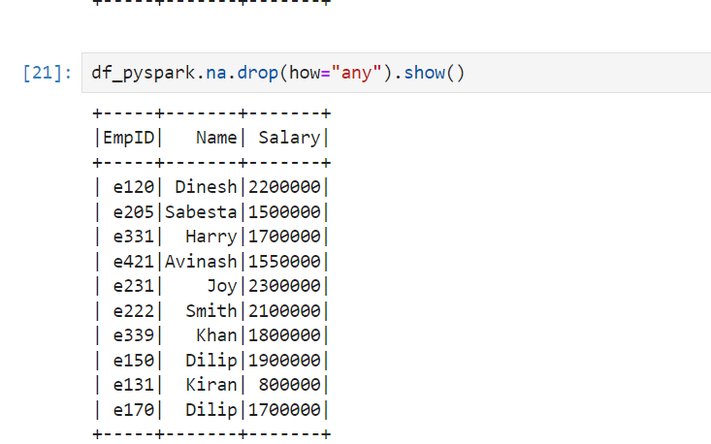

**Using threshold()**

**Sort() Function:**

**……..Continued below……..**

**For descending Order:**

**Sorting with two Columns:**

**----------Continued Below----------**

**Joins**

**Two datafrmaes on which we will perform joins:**

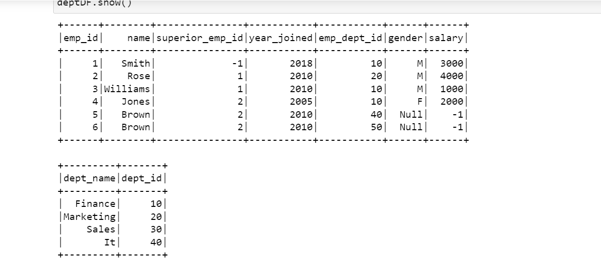

**Inner Join:**

**Outer Join:**

**Left Join:**

**Right Join:**

**LeftSemi Join:**

**Leftanti Join:**

